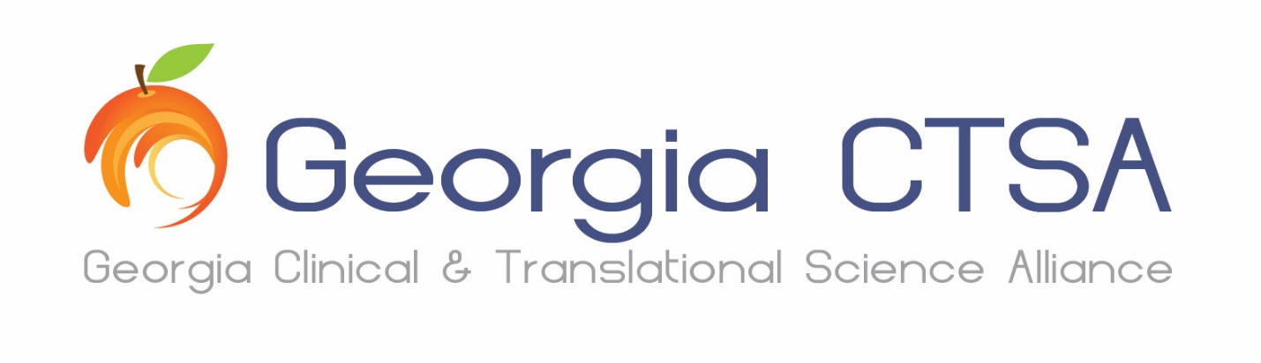
Team Science Award of Distinction for Early Stage Research Teams

Team Name:Click or tap here to enter text.

Lead PI(s):Click or tap here to enter text.

Contact email:Click or tap here to enter text.

Description of your team’s research
Max word count: 250
Click or tap here to enter text.

List of all members of the team and their professional titles and affiliations

Click or tap here to enter text.

A description of each member’s role and what expertise they bring to the team

Click or tap here to enter text.

Description of high quality, productive teamwork  Max word count: 100 | Shared abstracts, publications or scholarly works at any stage (e.g., submitted, in press, in revision) involving 2 or more team members, shared mentoring responsibilities, shared pilot grant applications, shared resources, etc.)
Click or tap here to enter text.

Interdisciplinary nature of the work  Max word count: 100 | How the interdisciplinary nature of the team was leveraged to accomplish the scientific aims and/or translational impact
Click or tap here to enter text.

Evidence of potential impact on health of individuals or communities  Max word count: 100 | Clinical protocols, population studies, evidence-based policies citing team’s research outputs, public prizes, membership to advisory councils for civic organizations, trainings for professionals, practice guides, formal guidelines, executive summaries, tool kits, contributions to public debate or appearances as media experts (webinars, podcasts, briefs), development of medical technologies
Click or tap here to enter text.

Innovation in teamwork  Max word count: 100 | Evidence of novel approaches to ensuring high functioning of the team (e.g., use of team-oriented collaborative tools, development of novel methods for team collaboration)
Click or tap here to enter text.

